[Deep Learning A-Z™: Hands-On Artificial Neural Networks](https://www.udemy.com/course/deeplearning/) - Udemy

Input layer: an input to start the prediction.

Output: a value that we want to predict price, someone leaves the bank, someone stays.

Hidden layer: information comes through the senses, and it goes through billions and billions of neurons before it gets to the output.

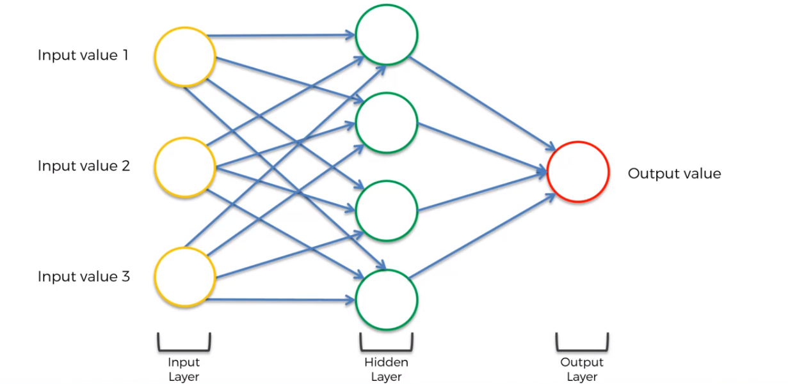

Deep learning: when we have lots of lots of hidden layers (just like a human brain).

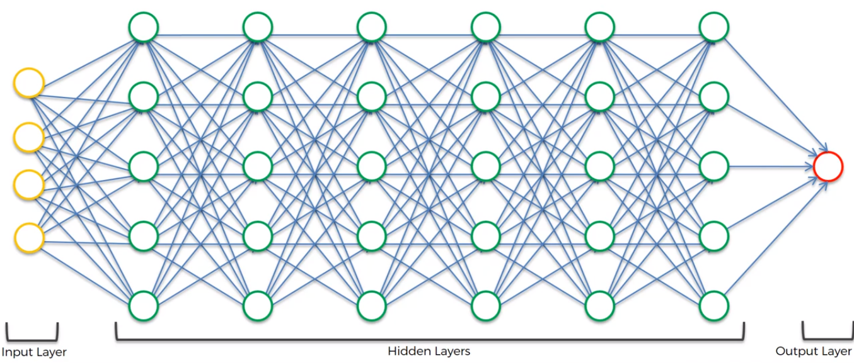

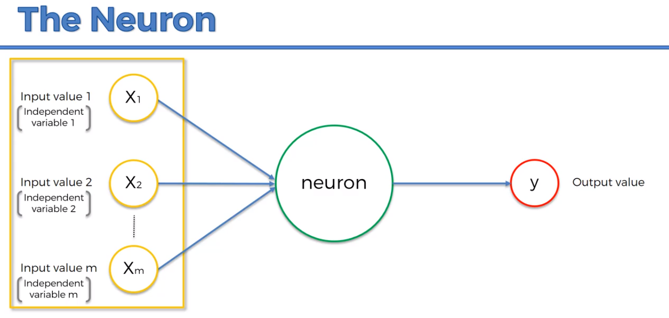

We need to standardize the variables, where they have a **zero mean** and **variance of 1.**

**S**ometimes we want to make them similar (the same range of values), so we do normalization, where we subtract the min value and then we divide by (max – min).

Its going to make it easier for the neural network to process them if they all about the same value, because they are going multiplied and added up several times.

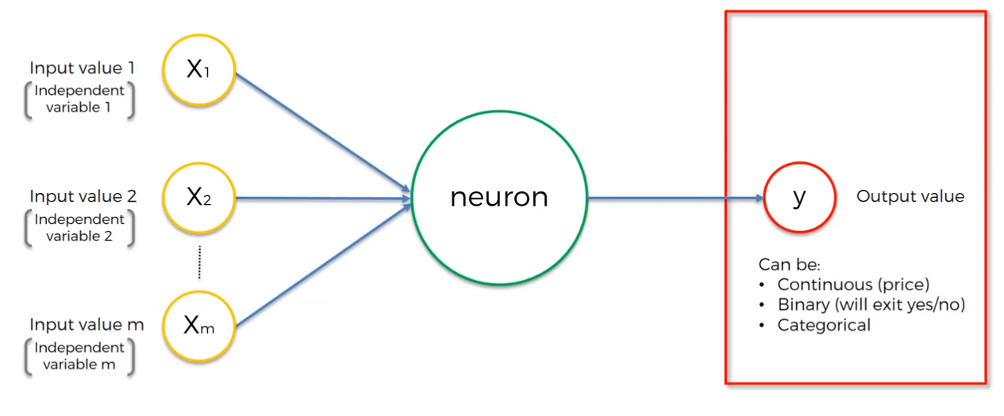

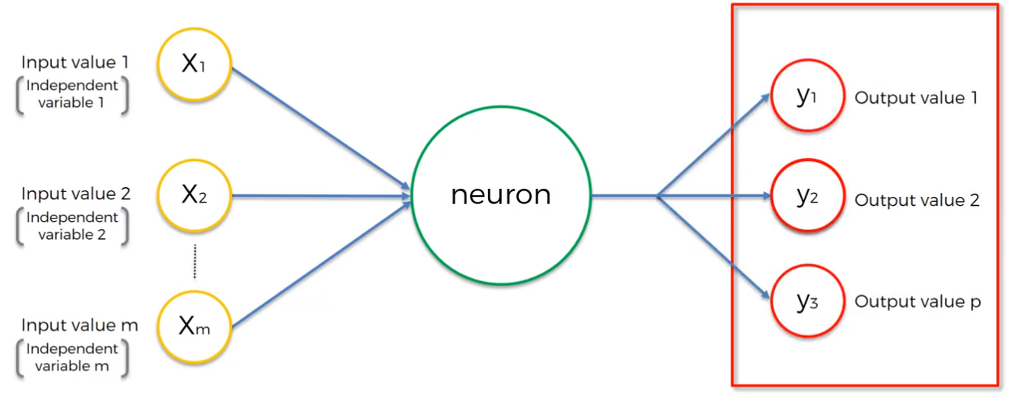

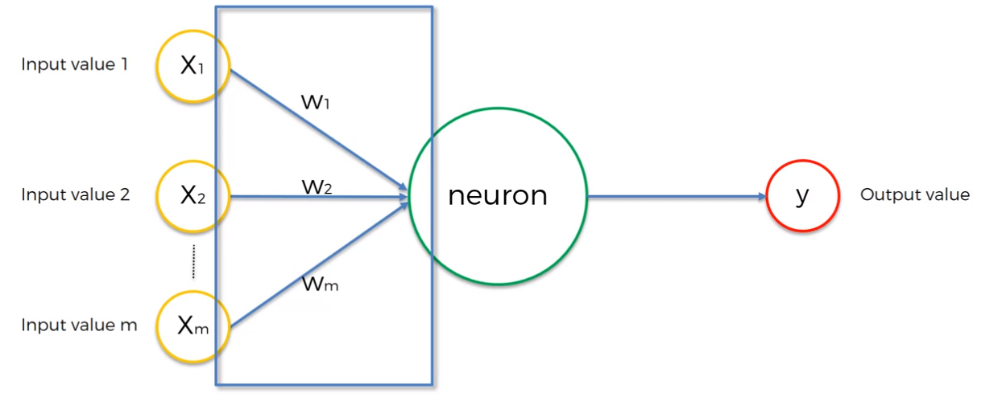

We add the weights then we apply a function Phi:

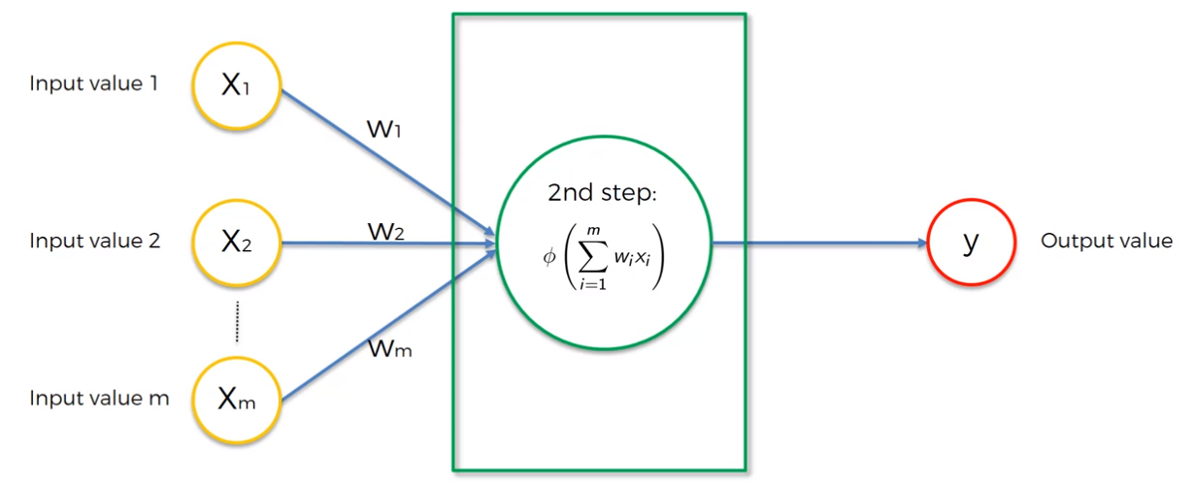

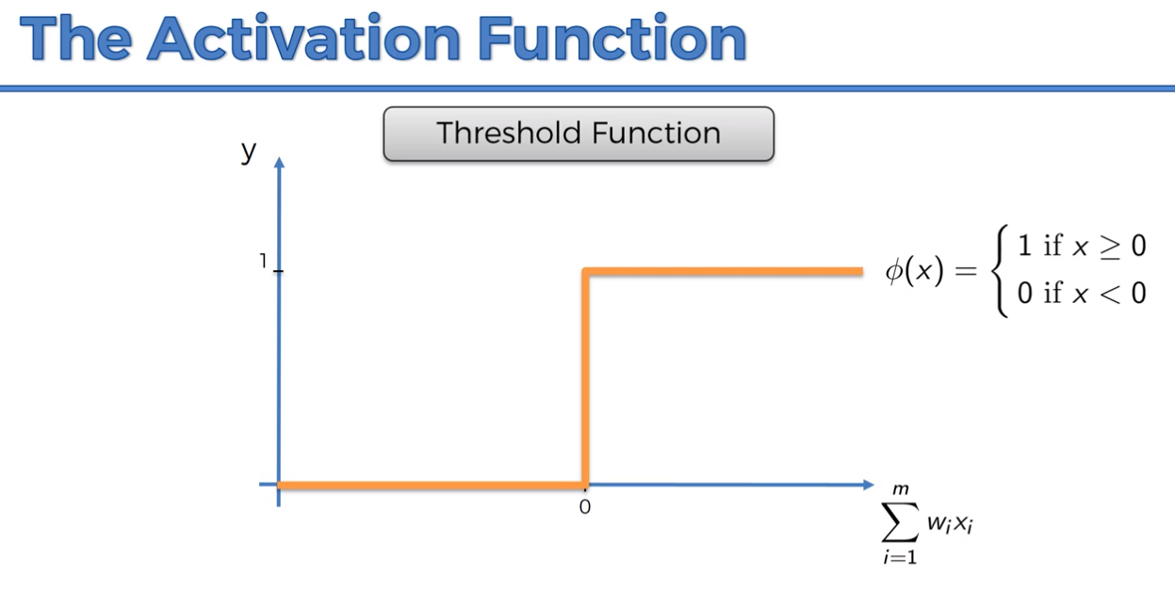

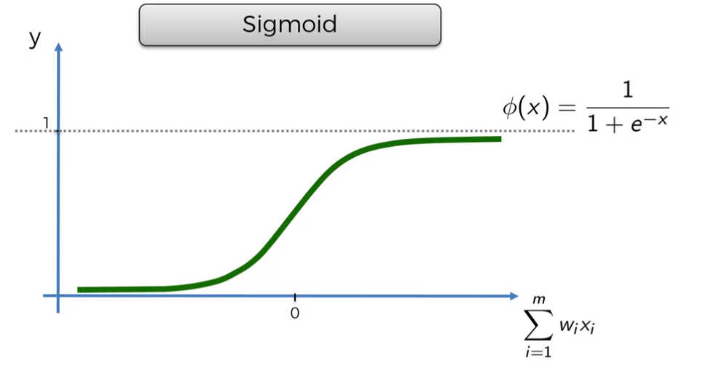

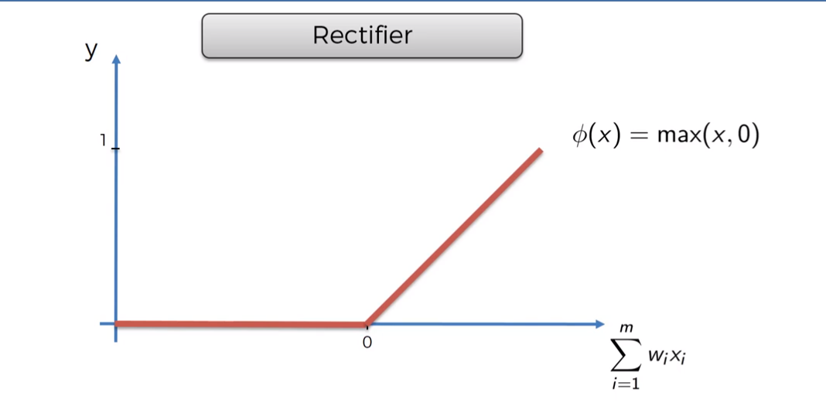

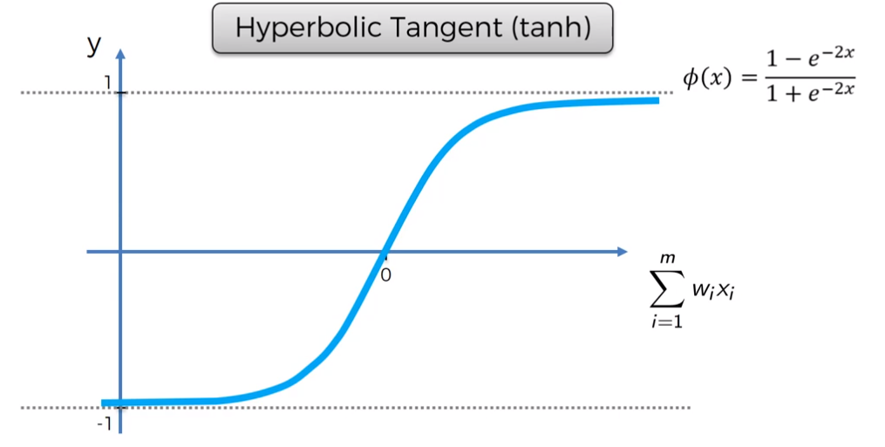

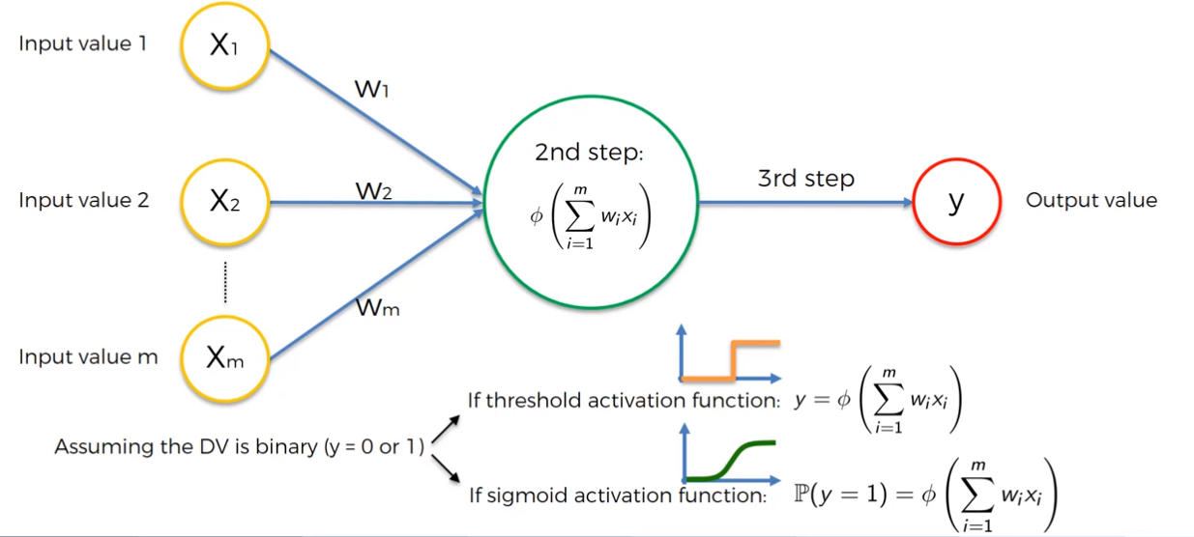

The sigmoid functions tells us what is the probability of $y$ being 0 or 1.

What we will usually do:

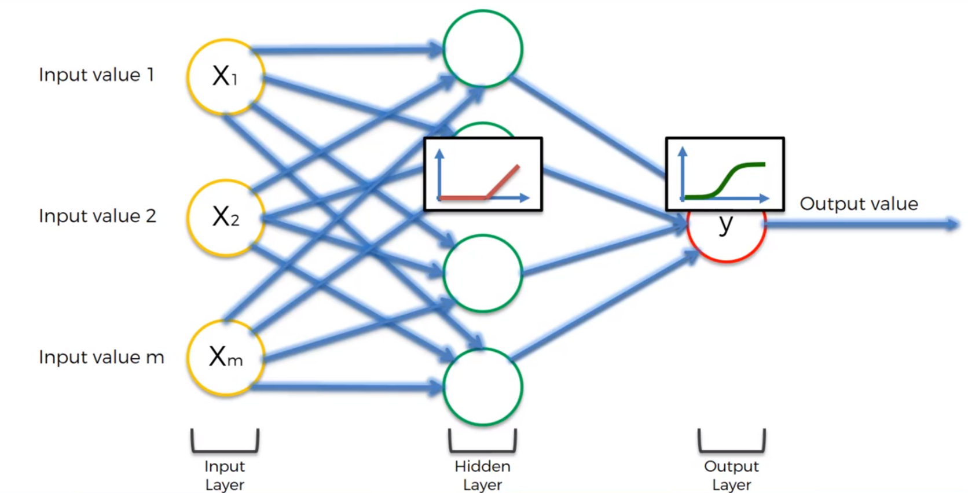

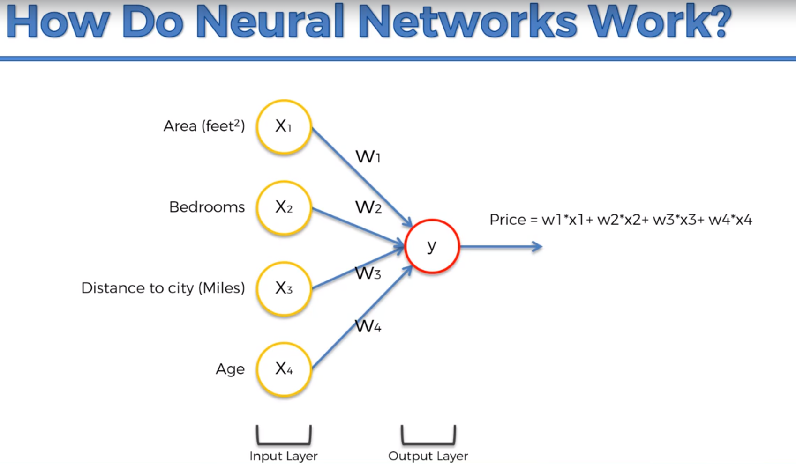

Why would this neuron be only linked to Area and Distance?

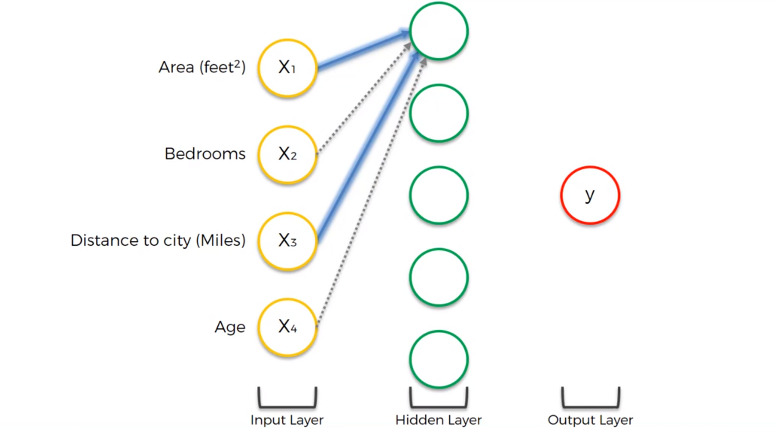

Well that could mean that normally the further away you get from the city,

the cheaper real estate becomes, and therefore the space in square feet of properties

becomes larger. So for the same price you can get a larger property the further away you go from the city. So these synapses will have a larger weight than the other two.

The neuron will fire up, whenever the criteria is met with respect the parameters (Area, Distance).

Therefore, this neuron doesn’t really care about bedrooms and age.

After training, this neuron for example will think that Area + Bedrooms + Age would be important:

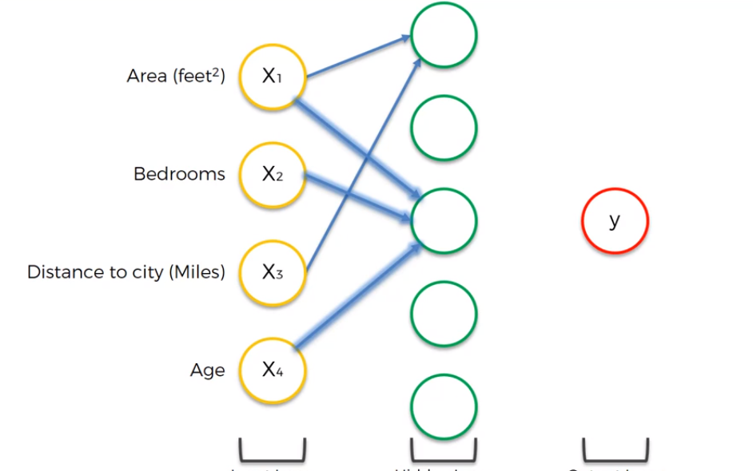

Maybe some families with children prefer a new property (the age of property is lower).

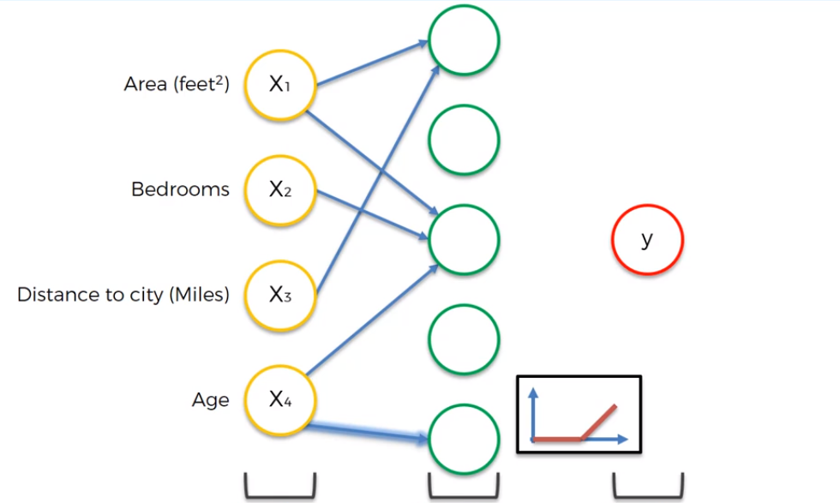

For example: properties that are over 100 years old, could be deemed as historic. That’s a good example where we use the rectifier function.

The neural network would also pick up things we never thought about, for example, bedrooms + distance may for some reason contribute to the price.